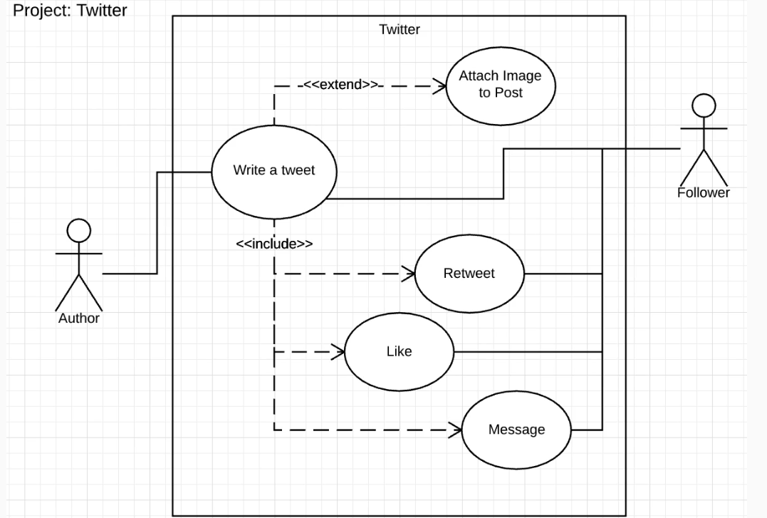

USE CASE DIAGRAM FOR TWITTER CLONE